The Brendan task

Gestructureerde opdracht over ‘second-order-denken’, met gefaseerde opbouw voor leerlingen onderbouw havo/vwo.

Doelen
- begrip van geschiedenis
- stimuleren van denken dat gericht is op ‘hoe kennen we het verleden’
- stimuleren van historisch besef (standplaatsgebondenheid / inlevingsvermogen)
- begrip van ‘historische context’
- ontdekkend leren van perspectieven op bronkritiek
- niveaus van broninterpretatie herkennen
- training van Engelse taal
- kennismaking met de geschiedenis van Groot-Brittannië

Hoofdoel opdracht
Beantwoorden van de vraag:
“Did an Irish monk land in America about 1.000 years before Columbus?”

Basis
Fase 1: het verhaal
Fase 2: Beschouwing van buitenaf. toevoeging van contextueel bronmateriaal. Het bronmateriaal geeft meer informatie over de historische context van de randvoorwaardelijke aspecten van de reis: het schip waarmee Brendan voer, de geografische aspecten en windrichting.
Fase 3: Beschouwing van binnenuit. Proberen met argumenten vanuit het verhaal te komen tot een antwoord op de hoofdvraag, Leerlingen worden op weg geholpen door een nadere toelichting op het begrip ‘interpretatie’.
Fase 4: Beschouwing van binnenuit met uitbreiding.
Verdieping
Fase 5: Beschouwing van de tekst als geheel. Soort tekst en verhalencontext van de vroege middeleeuwen.

Het verhaal
Introduction: The Story of St. Brendan
(All the underlined words are explained at the end)
Sometime between the yaer 900 and the year 1000, someone wrote down an amazing story. It was written in the Latin language.
The story described ho wan Irish monk called St. Brendan went on a long voyage lasting 7 years to a land called the Land of Promise. We know that Brendan lived in Ireland between (roughly) 486 and 578. There are things in the story that make some peiple think Brendan might have crossed the Atlantic Ocean and reached America.
It is quite likely that the story comes from earlier times than 900, but we don’t know that. There are more than 120 versions of the story in Latin and more in other languages. They all say almost the same things.
The Voyage of St. Brendan
(This is a shortened version of the story. Is misses out some of the adventures of St. Brednan and his crew of monks. Allt the underlined words are explained at the end.)
St. Brendan lived at Clonfert in Ireland. He was head of a community of 3000 monks. One day a monk called Barrind visited Brendan and told him about a Land of Promise across the sea in the wwest. It was a wonderful place, special to God.
Brendan decided to go and find this Land of Promise. He and his monks build a boat with a wooden frame, covered in tanned leather. He put food and drink in the boat to last for 40 days, and also spare leather and fat for greasing it.
Brendan set out with 17 other monks and sailed west. After 15 days they landed on a tall rocky island. A dog led them to a settlement, where they found a meal waiting fort hem. They stayed for 3 days without seeing anyone, but food was always set out ont the table for them.
Next they landed on a island with lots of streams, all full of fish. It was called the Island of Sheep, because flocks of sheep roamed over it all year around. A man gave them food.
Then they visited another island that was rocky and bare. They made a fire to cook food, when suddenly the “island” began to move. The monks quickly jumped into theur boat, just in time to see the “island” swim off with the fire still burning. St. Brendan told the monks that it was the biggest fish in the ocean, and iets name was “Jasconius.”
After this the monks sailed to an island called The Paradise of Birds. They hauled their boat almost a mile up a narrow stream, and found a huge tree covered in white birds. A bird flew down and told Brendan that the birds were men’s spirits, and that he would have to search 7 years to find the Land of Promise. The birds sang hymns and chanted prayers at the right times of day. A man called the Steward brought food across tot he monks. (He was the man who had given them food on the island of Sheep.)
The monks were at sea for 3 months before they came to another island. They were so exhausted that they could hardly row the boat against the wind. On the island they found monks wqho had agreed to keep silent (so that they could concentrate on thinking about God). The monks had been there 80 years, and none of them had been ill. They showed Brendan how their lamps were lit by a miraculous flaming arrow each evening.
The monks had many adventures before they found the Land of Promise. Many times they found themselves back at the Island of Sheep. But they still continued their search. Once they found a column of crystal sticking up out of the sea. It was surrounded by a mesh that was the color of silver and as hard as marble. They found an opening in the mes hand took the boat close tot he column. St. Brendan and this monks measured the column. Its four sides were aech 700 yards long. The monks then look hold of the mes hand pulled the boat out tot he open sea.
Another day the monks were blown towards an island, and Brendan was worried. He heard the sound of a forge, with the thud of a hammer on an anvil. As the monks came near the island, an islander came out and threw molten metal and hot stones at them. A lump flew 200 yards over their heads and fell into the sea. The sea round it boiled, and smoke rose up. Then more islanders rushed down th the shore and threw hot stones at the monks. Soon it looked as if the whole island was on fire. The sea boiled, the air was filled with a howling sound, and there was a terrible smell. Brendan told his monks they had reached the edge of Hell. They sailed away as fast as they could.
In the end the Steward from the Isle of Sheep had to help them find the Land of Promise. They left the Isle of Sheep again, and after 40 days at sea they sailed into a great fog. The Steward said the fog always encircled the Land of Promise.
At last they saw a great light, and the boat came to the shore. The land was full of fruit trees. They explored for 40 days, but still did not come to the end of the land they were exploring. Finally they reached a big river, which Brendan said they would not be able to cross. A man came to them, spoke to them by name, and said the land would eventually be made known to all people at a time when Christians were being persecuted. Brendan gathered samples of fruits, and sailed home with his
monks.

Verklarende woordenlijst

Latin
Latin was the language people used for writing in Brendan’s time.
Almost the only people in Europe who could write were Christian
monks and priests. Christian priests continued to use Latin for
most of their writing for more than 1,000 years after Brendan’s
time.

Monk
Monks are men who spend their lives studying God, worshipping
him, and trying to do what God wants. They live together in communities
called monasteries, helping each other and worshipping
God together.

Communities
Communities are groups of people who live or work together.

Land of Promise
This means a land where everything is right for people to live a
great life. It’s the sort of land where it is easy to find food, where all
the plants and flowers are beautiful and grow well, and the climate
is comfortable.

Tanned leather
This was specially toughened leather. It was soaked in juice from
the bark of oak trees to make it stronger.

Column
A column is shaped like a pillar or a fat post, usually taller than it
is wide.

Crystal
The monks meant the column was hard, bright, and semitransparent.

Mesh
A mesh is like the sort of pattern you get with a net: squares with
lines or gaps between them.

Marble
This is a very hard kind of stone, often used for expensive buildings
or for gravestones.

Forge
A forge is where blacksmiths make tools or weapons out of hot
iron.

Anvil
This is a big block (usually made of iron) that blacksmiths use.
When they are beating some hot iron into shape with a hammer
(to make a tool or a weapon), they rest the hot iron on the anvil.
Opdracht 1
Discussieer in groepen van maximaal vier leerlingen in hoeverre het mogelijk is dat St. Brendan Amerika heeft bereikt. Alle genoemde argumenten die jullie bespreken noteer je.
Opdracht 2
Een andere vraag die wordt opgeroepen is: ‘is het mogelijk wat Brendan heeft gedaan?’

Klassengesprek: alle argumenten passeren de revue. De uitkomst van discussie is onder meer dat we meer moeten weten van het verhaal en aspecten ervan moeten onderzoeken.
Het eerste doel – met deze discussie – is de gedachte te ontlokken dat niemand op basis van dit verhaal kan zeggen: het klopt, of het klopt niet. Het verhaal behoeft een vorm van rechtvaardiging. De rechtvaardiging kan gevonden worden in bewijsmateriaal.

Fase 2
Evidence 1
How far could a leather boat have managed to sail? In the 1970s someone made a leather boat just like the one St. Brendan would have used and tried to sail it from Ireland to America. He was called Tim Severin, and he and four other sailors sailed from Ireland to Iceland in the summer of 1976, and then from Iceland to Newfoundland in the summer of 1977. They had to sail through some rough seas, and past icebergs but the boat did not sink and they made it successfully! Below is a photograph of Tim Severin’s reconstruction of a boat from Brendan’s time. The picture shows the boat just as it reached the coast of Newfoundland. Scientists think that the climate was probably warmer in the times when Brendan was sailing than it is now. Brendan might not have met such gales and rough seas as Tim Severin did on his voyage. What do we know about the sort of boat St. Brendan would have used?

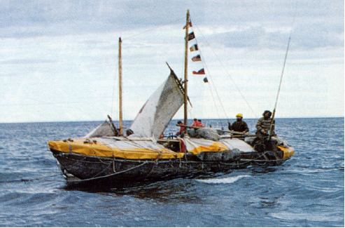

Evidence 2


The boat Brendan would have used would have been made of
specially toughened leather, sewn over a wooden frame. The boat
would have used sails on the open sea, and people would have
rowed it with oars when it was near the land.
Below is an Irish boat, copied from a carving done on a stone
pillar sometime between 700 and 800.

Evidence 3
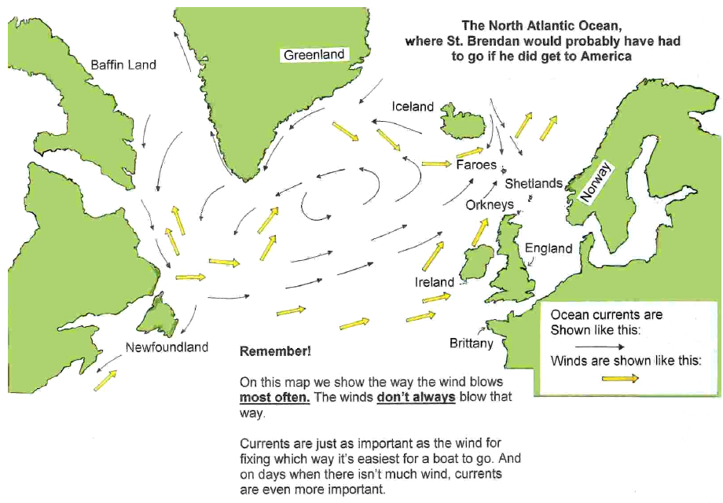

The North Atlantic Ocean, where St. Brendan would probably
have had to go if he did get to America.

Evidence 4

What do we know, or think might be true, about St. Brendan?
- We know Brendan lived in Ireland between (roughly) 486 and
578.
- We know he sailed to Iona, an island several miles off the west
coast of Scotland.
- We think it is very likely that he sailed to Brittany in France.
- We think it is possible he visited the islands beyond the north of
Scotland.
- We know many Irish monks made voyages in the seas near Ireland
at this time.

Opdracht 3
Leerlingen nemen het bewijsmateriaal in overweging en wegen opnieuw af wat hun antwoord op de hoofdvraag is.

Toelichting bij de bronnen:
- Tim Severin wist waar hij naartoe zou gaan, Brendan niet
- De boot van Severin had slechts vier opvarenden. Dat scheelt aanzienlijk in voedsel (bevoorrading).
- Je kunt stellen dat het mogelijk is Amerika te bereiken met een dergelijke boot, maar dat zegt niet dat de reis daadwerkelijk heeft plaatsgevonden.

Fase 3

Opdracht 4
- Make a list of the three things in the story that would best
back up the claim that Brendan reached America. How do they
back up the claim?

- Pick the three things that seem to you
hardest to accept. How do they make it hard for us to believe
that the story shows that Brendan reached America?

Toelichting bij opdracht 4
De a-opdracht is voor veel leerlingen moeilijk. Het vinden van drie bewijzen vindt daarom vooral plaats in combinatie met een argument van buiten het verhaal of doordat een verhaalelement wordt voorgesteld als een natuurverschijnsel dat daadwerkelijk heeft plaatsgevonden.

Opdracht 5
- Kijk naar de twee afbeeldingen hieronder en beschrijf per afbeelding welk dier je ziet.



Toelichting bij opdracht 5:
De leerlingen worden in eerste instantie gedwongen om een keuze te maken, maar wie goed kijkt ziet in elke afbeelding twee dieren. Kortom, het is een kwestie van interpretatie wat mensen zien in een bepaalde afbeelding. De interpretatie van waarneming kan dit verschillend zijn. Door die ‘bril’ kan ook gekeken worden naar teksten, bijvoorbeeld de tekst van Brendan. De manier waarop je naar de tekst van Brendan kijkt bepaalt hoe specifieke gebeurtenissen binnen het verhaal te interpreteren.

- Bestudeer het deel van het verhaal dat gaat over de ‘column’. Bedenk twee manieren waarop je de tekst over de ‘column’ kunt interpreteren.

Toelichting bij vraag b

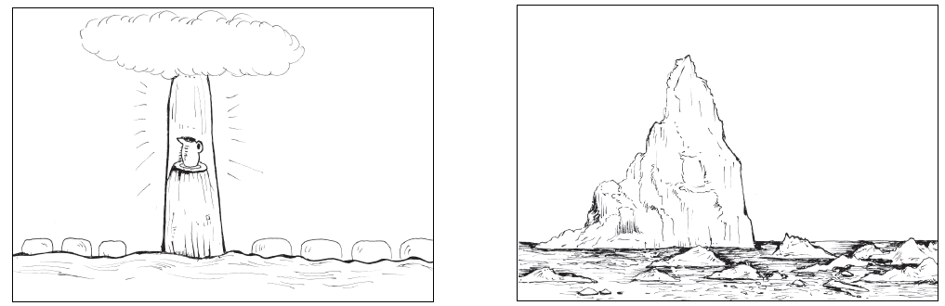

- Bediscussieer opnieuw de hoofdvraag: “Did an Irish monk land in America about 1.000 years before Columbus?” Noteer eventuele nieuw aangedragen argumenten.

Fase 4

Evidence 5

One day after they had said Mass, they saw a column in the sea. It
did not appear to be far away, and yet it took them three days to
get near it. When the Man of God came near to it, he couldn’t see
the top, because it was so high. It was higher than the sky. All around
the column was an open-meshed net, with openings so large the
boat could pass through the gaps. They didn’t know what the net
was made of. It was silver in color, but seemed to be harder than
marble. The column itself was of clearest crystal. The monks pulled
on the meshes of the net to get the boat through it. There was a
space about a mile wide between the net and the column. They
sailed all day along one side of the column, and could still feel the
heat of the sun through its shadow. The Man of God kept measuring,
and the side was 700 yards long. It took four days to measure
all four sides. On the fourth day they saw an ornamental church
plate and jug in a window of the column. They were made of the
same material as the column. Saint Brendan took hold of the plate
and the jug, and said, “Our Lord Jesus has shown us a miracle, and
given me these two gifts so that other people will believe us.”

Opdracht 6
Voordat je definitieve conclusie formuleert wordt er een bewijsstuk toegevoegd: een uitgebreidere beschrijving van de gebeurtenissen rondom de ‘column’. Tot nu toe heb je gewerkt met een samenvatting. Evidence 5 is een uitgebreidere beschrijving van dit deel van het verhaal.

- Lees evidence 5. Verandert je overtuiging na het lezen van de toevoeging aan dit verhaal? Licht je antwoord toe.

Toelichting bij vraag 6
‘Mass’ staat voor een religieuze dienst en ‘the Man of God’ is Brendan. Kortom, het verhaal heeft een religieus karakter en is ook niet bedoeld als primair een feitenrelaas.

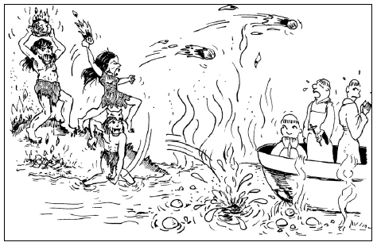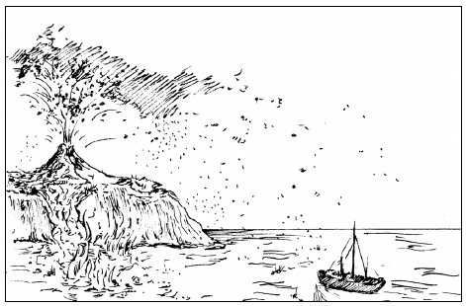

- Lees opnieuw het verhaaldeel over de “Hell” en lees daarna evidence 6. Vraag jezelf af of dit deel van het verhaal ‘natuurgetrouw’ of ‘bovennatuurlijk’ geïnterpreteerd moet worden. Geef vervolgens opnieuw antwoord op de hoofdvraag.

Evidence 6

Some facts we have good reasons to be sure about
• The Faroe Islands have had large flocks of sheep on them for
a very long time.
• Iceland has active volcanoes on it that still erupt even nowadays.
• There is very often fog in the area near Newfoundland.

Verdieping
Verplaatsen in de denk- en leefwereld van de vroege middeleeuwen is voor leerlingen niet eenvoudig, zo niet buitengewoon moeilijk en ingewikkeld. De verdiepingsfasen van deze opdrachtenserie gaat in op de denk- en leefwereld van de middeleeuwer. Doel hiervan is vanuit een verdiepend perspectief opnieuw antwoord te geven op de hoofdvraag van deze serie.

Fase 5

Evidence 7

What are writings from those days (500–1000) usually like?
They generally don’t give many of the details we might expect
(times, dates, or where things happened) and are often vague about
exactly what happened. When they give details, they often say different
things about the same event.
Often people who wrote in these times weren’t trying to get the
details right. They weren’t writing news reports. They might have
been trying to show how a good person ought to live, or how God
helped good people and punished bad ones. Other times they might
be telling the story of a great hero.
A very common sort of Irish story was the “imram,” which was a
made-up tale about a sea voyage. People liked hearing such stories.
But most imrams were probably written later than the time when
the story of St. Brendan’s voyage was written.
Some people think “The Voyage of St. Brendan” is different from
the usual writings of the time. For instance, one lady who is an
expert on writings from 500 to 1,000 is puzzled because “The Voyage
of St. Brendan” doesn’t keep going on about Brendan doing
miracles. She says that when writings from this time are about
saints, most of them make sure to have the saint doing lots of
miracles. (That is because they wanted to show how good a saint
he or she was, and how powerful God is.) But in “The Voyage of St.
Brendan,” Brendan doesn’t do miracles himself.

Opdracht 7
Evidence 7 beschrijft de context van geschriften in de vroege middeleeuwen.

Lees evidence 7 en beargumeteer of deze contextuele informatie de geloofwaardigheid van het verhaal van St. Brendan vergroot of verkleint.

Toelichting bij evidence 7
Deze tekst moet er toe bijdragen dat mensen in de middeleeuwen afwijkende denkpatronen hadden. De vanzelfsprekendheid van bijgeloof in de middeleeuwen heeft invloed op de totstandkoming van een verhaal. Dat bewijst dat het verhaal van St. Brendan anders geïnterpreteerd moet worden dan bijvoorbeeld een hedendaagse novelle. In deze fase komt het vooroordeel van ‘domheid’ van de gemiddelde middeleeuwer aan de orde. Het feit dat de middeleeuwers een vulkaan en een ijsberg niet konden waarnemen zoals hedendaagse mensen dat kunnen maakt de middeleeuwer dom.
De normen, waarden en tijdsbeeld van waaruit de middeleeuwer beoordeeld kan worden moet voortdurend onder de aandacht van leerlingen gebracht worden. ‘

Opdracht 8
Lees de onderstaande korte conversatie tussen een leraar en twee leerlingen. Jilly en Don hebben – net als jullie – nagedacht over een antwoord bij opdracht 8. Bestudeer het antwoord van Don.
Leg uit wat Don met zijn argumentatie duidelijk wil maken.

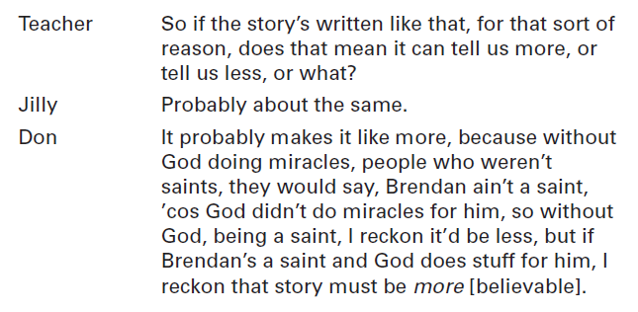

Opdracht 9
Een belangrijke vraag is met wat voor soort verhaal we eigenlijk te maken hebben?
Hieronder staan vier mogelijke antwoorden. Kies het antwoord dat volgens jou het beste antwoord op de vraag is.

- It is just a religious story about what a holy man St. Brendan was, showing what wonderful things he did to find the Land of Promise that was special to God.
- It is a story about a real voyage that St. Brendan made to America.
- It is a story based on real events, but meant as a religious story about how holy St. Brendan was.
- It is an ‘imram’—just an exciting made-up voyage story.

Evidence 8

Possible clues as to whether Brendan reached America—what’s been
found in Iceland.

Historians know that:
• Long after Brendan’s time (about 870) the Vikings started to
settle in Iceland. They found Irish monks there.
Possible clues as to whether Brendan reached America—what’s been
found in Greenland.

Historians know that:
• When the Vikings first reached Greenland in about 982, they
found the remains of a skin-covered boat and some stone huts.
• The Inuit used skin-covered boats.
• The Inuit usually dug homes out of the ground, and didn’t
use stones to build them.
• At the time the Vikings arrived, the Inuit may not have reached
southern Greenland.
Possible clues as to whether Brendan reached America—what’s been
found in Vinland.

Historians know that:
• The Vikings reached Vinland (their name for the northeast
coast of what we call Canada and America) between 986 and 1000.
They met people who told them about strange men who wore white
clothes and walked in a procession carrying poles with white cloths
fixed to them, yelling loudly. The Vikings assumed they meant
Irishmen.
• The Vikings called part of Vinland “White Man’s Land,” and
another part “Greater Ireland.”
• Later one Viking met people speaking a language he didn’t
understand. He thought it was like Irish.
• Carvings have been found on a rock in West Virginia that
look similar to ancient Irish writing. One expert in old languages
thinks they are ancient Irish writing. He thinks they say, “At the
time of sunrise the sun’s rays just reach the notch on the left side,
when it is Christmas Day.” (A “notch” in the rock is a line cut in the
rock.)

Opdracht 10
Als laatste stap worden enkele vragen voorgelegd die je laten nadenken over algemene ideeën die je hebt ontwikkeld met betrekking tot geschiedschrijving.

- Wat zou je zeggen tegen iemand die stelt dat er niets zinnigs over het Brendan-verhaal te vertellen valt?
- Wat zou je zeggen tegen iemand die stelt: ‘we waren er niet bij, dus iedereen kan erover zeggen wat hij of zij nodig acht.’
- Wat zou je zeggen tegen iemand die stelt: ‘of je gelooft het verhaal, of je gelooft er helemaal niet in.’

